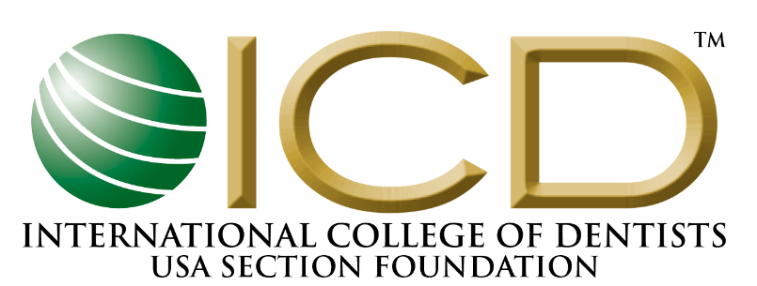
2024 GRANT AND PROJECT APPLICATION

INSTRUCTIONS FOR THE APPLICATION PROCESS
Thank you for your interest in the International College of Dentists (ICD) USA Section Foundation’s General Grant. With the large number of applications, the USA Section Foundation receives, as well as the varying amount of funds available for distribution each year, not all approved grants will be funded at the requested amount and some very worthwhile applications may not be funded in any given year. However, it is to your benefit to follow these instructions carefully.
All grants are for projects to be completed within one year of receiving the grant. No grant funds can be used for previous year projects.
*Important: SAVE this file to your computer before completing the application or your data will be lost. Please save the file as Project Name – General Grant Application.
*Please type all information. Submissions must be in English and U.S. dollars.
- Submit Application and each of the following items electronically as a PDF to kylie@usa-icd.org:
      - Application Form
      - Anti-Discrimination Statement (where applicable)
      - Listing of Board of Directors and/or Organizational Officers
      - Organizations Conflict of Interest Statement
      - A Copy of the Current IRS Determination Letter Indication 501(c)(3) Status
      - List of Sponsoring Organization’s Board Members
      - The Previous Year IRS Form 990
      - Proposed Budget and Allocation of ICD USA Section Foundation Grant Funds
- Complete the required part of the application. Be Concise.
  - Project Purposes
  - Project Goals
  - Project Objectives
  - How will the Grant/Project be Implemented
  - List the Major Phases Involved in this Project
  - Include the Approximate Dates for Implementation and Project Time Period
  - Explain how the Grant/Project will be Evaluated
  - Explain how the Outcome will be Assessed
- IMPORTANT: Attach a proposed itemized project budget including a DETAILED breakdown as to how the Foundation's funds will be utilized for your grant project. In addition, please include the overall annual budget of your organization. Grants will not be considered without a detailed budget.
- All Grant winners will be notified by the end of December. If additional information is required, please contact Kylie Evans (kylie@usa-icd.org).
- Grants must be submitted by July 31st, late applications will not be accepted.
Send completed application via:
Email as a SINGLE PDF (multiple files will not be accepted) to:
Kylie Evans - kylie@usa-icd.org
Subject Line: General Grant – Project/Company Name

GRANT REQUIREMENTS
Please read prior to submitting a grant application.
Maximum Dollar Amounts for Grants
Typically, grants are awarded in the amount of $5,000.00 or less but factors such as programs costs, reserve funds, other funding sources, etc. are considered.
Restrictions - The Foundation Will Not Fund
- The purchase of major equipment costing more than Three Thousand Dollars ($3,000.00).
- University or institutional overhead costs.
- Salaries (this includes any personnel costs or doctor’s fees).
- Travel and any related travel expenses.
- Questionnaires and surveys.
- Capital Projects.
- Endowments.
- Land and/or building acquisitions.
- Social services of a non-dental nature.
- Programs that are the government’s responsibility and are supported by tax revenues.
- The development, maintenance, or revision of temporary or permanent museum type dental exhibits.
- Funding of political candidate’s activities or lobbying efforts.
- Schools below the college level.
- Dinners, tables, or tickets to fundraising events.
- Advertising in charitable publications.
- Promotional activities such as trophies, prizes, or trips.
- Endowed chairs.
- Funding to the general funds of other foundations or organizations. However, specific projects or programs conducted by other foundations or organizations may be considered for grants.
- Essays.
- Research.

Grant and Project Application Form
All applications must be received by July 31st
Project Title:
Name of individual applying for the grant:
Organization:
Street Address:
City, State, Zip:
Email:
Telephone:
Sponsoring Agency: Who will be responsible for the administration of the grant. The agency must be a 501(c)(3) organization or have similar non-profit international status.
Name of Sponsoring Agency:
Street Address:
City, State, Zip:
Telephone:
Website:
Funding Request | $_______________(US dollars)
Does this organization have ICD Fellow involvement?
____ Yes
If yes, please list the participating Fellows.
____ No
5. How many people will this project help:
- List other sources of funds available or applied for, regarding this grant project:
Sources and Amounts:
- Project Purpose:

- Project Goals and Objectives:

- How will the project be implemented:

- List the major phases of the project:

- List approximate dates of implementation and project time period:

- How will the project be evaluated:

- How will the outcomes of this project be assessed:

- The following items must be included with this grant application.
      - Application Form
      - Anti-Discrimination Statement (where applicable)
      - Listing of Board of Directors and/or Organizational Officers
      - Organizations Conflict of Interest Statement
      - A Copy of the Current IRS Determination Letter Indication 501(c)(3) Status
      - The Previous Year IRS Form 990
      - Proposed Budget and Allocation of ICD USA Section Foundation Grant Funds
- Failure to complete this form in its entirety and to submit all required components of the application will result in rejection of your grant application.
- I do hereby acknowledge that all information contained in this application and accompany documents are accurate. If the application does not meet the initial requirements, as set forth by the Foundation, the Executive Director will reject the application and send a letter of explanation.
- Reporting Requirements: See separate Grant Report Form guidelines.
______ Initial Here To Commit to Reporting Requirements
Principal Applicant Name and Title:___________________________________________________
Principal Application Signature:______________________________________________________
Date:_____________________________________________________________________________
Grant applicants will be notified by mid-December of the application year informing the applicant if they have or have not been awarded a grant. Approved funding will be available in January.

